**GENERAL HUMAN BIOLOGY UNIT 4**

**TASK 7 – Disease Transmission Practical**

**NAME: ____________________________________________ WEIGHTING: 7 %**

**DATE: ____________________________________________ MARK: ________ %**

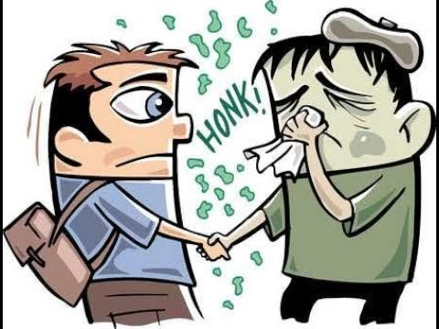

The presented assessment aims to assess your practical skills when using a microscope, your comprehension of scientific inquiry and your understanding of disease transmission. It is presented in three parts.

|  |  |
| --- | --- |
| Part 1: Microscope Practical Skills | **/12** |
| Part 2: Disease Transmission | **/12** |
| Part 3: Preventing Transmission | **/24** |
| **TOTAL** | **/48** |

**Part 1: Microscope Practical Skills (12 Marks)**

Our modern understanding of what disease is, and how it is transmitted, is thanks to the development of the microscope. We use microscopes to observe pathogens and their adaptations for transmission. It is important that you are able to use this revolutionary tool.

1. *Prepare a slide (4 Marks)*

Your task is to follow the supplied method to prepare a slide of an onion skin. Your teacher will be watching as you prepare the slide. You will only have 10 minutes to complete this.

Method:

1. 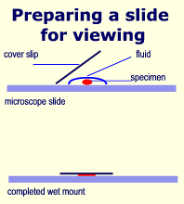Add a drop of water at the centre of the microscopic slide
2. Having pulled of a thin membrane from the onion layer, lay it at the centre of the microscopic slide (the drop of water will help flatten the membrane)
3. Add a drop of iodine solution on the onion membrane (or methylene blue)
4. Gently lay a microscopic cover slip on the membrane and press it down gently using a needle to remove air bubbles.
5. Touch a blotting paper on one side of the slide to drain excess iodine/water solution,
6. Place the slide on the microscope stage under low power to observe.
7. *Focus the microscope (4 Marks)*

Your task is to get your microscope focused on the 40x objective lens. You will have 10 minutes maximum. Once you have focused your microscope on the provided slide your teacher will look through the eyepiece to assess how well your microscope is focused.

1. *Use the microscope to create a drawing (4 Marks)*

Your final practical task is to create a scientifically accurate drawing of what you see in the microscope in the space below.

**Part 2: Conditions for Malaria Transmission (12 Marks)**

1. Observe the image below. Determine the width of the mosquito’s body depicted in the image.

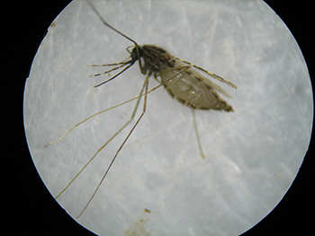*(2 marks)*

4000 µm

1. The mosquito is carrying the parasite Malaria. State the name of the transmission method that Malaria typically follows. *(1 mark)*

_________________________________________________________________________________

1. State two other ways that a pathogen can be transmitted. *(2 marks)*

_________________________________________________________________________________

The table below contains information about the prevalence of malaria in different African countries.

|  |  |  |  |  |  |  |  |  |  |
| --- | --- | --- | --- | --- | --- | --- | --- | --- | --- |
| **Country** | Kenya | Angola | Ghana | Benin | Botswana | Cameroon | Central African Republic | Ethiopia | Namibia |
| **Prevalence (per 1000 people at risk)** | 71 | 155 | 270 | 368 | 2 | 304 | 387 | 37 | 44 |

Observe the table below about humidity in these countries.

|  |  |  |  |  |  |  |  |  |  |
| --- | --- | --- | --- | --- | --- | --- | --- | --- | --- |
| **Country** | Kenya | Angola | Ghana | Benin | Botswana | Cameroon | Central African Republic | Ethiopia | Namibia |
| **Average Annual Humidity %** | 69 | 78 | 83 | 75 | 32 | 79 | 61 | 62.5 | 33 |

1. Using the data in the table above, describe what conclusions can be drawn about the relationship between humidity and malaria transmission? *(4 marks)*

__________________________________________________________________________________________________________________________________________________________________

_________________________________________________________________________________

____________________________________________________________________________________________________________________________________________________________________________________________________________________________________________________________________________________________________________________________________

1. The conclusions made from this data might not be as valid as they could be. Explain why this is the case. *(3 Marks)*

______________________________________________________________________________________________________________________________________________________________________________________________________________________________________________________________________________________________________________________________________________________________________________________________________________________________

**Part 3 Preventing Disease Transmission (24 Marks)**

Mosquitoes thrive when water is stagnant (untouched and still). This is why, after a heavy rain that produces puddles of water, there are more mosquitos.

With its equatorial climate, heavy rainfall, dense living conditions and economic dependence on trade and tourism, Singapore should serve as the perfect petri-dish for breeding malaria. And yet, the country was declared malaria free in 1982. This is due to the country’s strict rules about stagnant water; a person can be fined $100-$20,000 if they forget to empty the water from the bottom of their flower pots!

In an effort to reduce the prevalence of Malaria in his country, a Kenyan researcher decided to investigate ways of reducing the number of mosquitoes. Over the course of a year, he investigated the number of mosquito larvae in a stagnant town pond versus a pond that had been agitated by a pump.

The results of his experiment are below.

|  |  |  |  |  |  |  |  |  |  |  |  |  |
| --- | --- | --- | --- | --- | --- | --- | --- | --- | --- | --- | --- | --- |
|  | Number of mosquito larvae | | | | | | | | | | | |
|  | Jan | Feb | Mar | Apr | May | June | July | Aug | Sep | Oct | Nov | Dec |
| Stagnant Water | 126 | 115 | 108 | 103 | 95 | 100 | 107 | 112 | 118 | 128 | 120 | 128 |
| Agitated Water | 28 | 36 | 18 | 16 | 16 | 22 | 23 | 28 | 31 | 34 | 33 | 30 |

1. Graph the results on this experiment on the grid below *(6 marks)*



1. Write an aim for this experiment *(1 Mark)*

________________________________________________________________________________________________________________________________________________________________________________

1. Identify the: *(2 marks)*
2. Independent Variable: ____________________________________________________________________
3. Dependent Variable: _____________________________________________________________________
4. State a possible hypothesis for this experiment. *(2 marks)*

_______________________________________________________________________________________ _______________________________________________________________________________________ _______________________________________________________________________________________

1. Identify two controlled variables for this experiment and explain why they need to be controlled. *(2 marks)* _______________________________________________________________________________________ _______________________________________________________________________________________ ________________________________________________________________________________________________________________________________________________________________________________________________________________________________________________________________________
2. State two ways to improve this experiment and explain how they would increase the reliability of the experiment. *(4 marks)*

________________________________________________________________________________________________________________________________________________________________________________________________________________________________________________________________________________________________________________________________________________________________________________________________________________________________________________________________________________________________________________________________________________________________________________________________________________________________________________________________________

1. What conclusions can be drawn from this data about how to limit the transmission of malaria? *(3 marks)*

____________________________________________________________________________________________________________________________________________________________________________________________________________________________________________________________________________________________________________________________________

1. Another scientist proposed that adding fish to the pond would be a better than agitating the water this is because the fish consume the mosquito larvae. Design an experiment that tests to see if adding fish to a pond would reduce the number of mosquito larvae. *(4 marks)*

________________________________________________________________________________________________________________________________________________________________________________________________________________________________________________________________________________________________________________________________________________________________________________________________________________________________________________________________________________________________________________________________________________________________________________________________________________________________________________________________________________________________________________________________